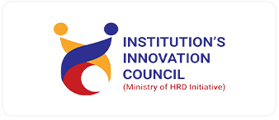
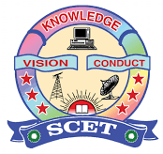
IIC REPORT Q1 EEE 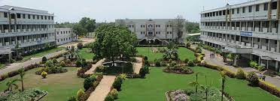

INSTITUTION’S INNOVATION COUNCIL (IIC)
SWARNANDHRA
COLLEGE OF ENGINEERING AND TECHNOLOGY
Seetharampuram, Narsapur.

Report of

Workshop on Prototype/Process Design and Development
Collage | Swarnandhra Autonomous
Department | SCET -EEE

Academic Year | 2025-2026
Program driven by | IIC calendar Activity
Quarter | IV
Activity Name | National Youth Day
Programme Type | Level -2 Workshop/ Exposure visit
Programme Theme | Q4
Program Stats Date | 12/01/2026
Program Ending Date | 12/01/2026
Number of Students Participants | 50
Number of Faculty Participants | 6
Number of Expert Participants, If Any | 1
Expenditure, If Any | ---
Mode of Delivery | offline
Objectives | Inspiring speeches  Informative videos  Interactive discussion  Youth feedback about interviews

Benefits in terms of learning/skill/knowledge development | Value-Based Learning, Personality Development, Teamwork & Collaboration, Career & Motivation Guidance
Program Coordinator (S) | B.subrahmanyam

Report:

The Department of Electrical and Electronics Engineering at Swarnandhra College of Engineering and Technology, in association with the Institution's Innovation Council (IIC), organized an activity on the occasion of National Youth Day to commemorate the birth anniversary of Swami Vivekananda.
The program aimed to inspire students with the values and teachings of Swami Vivekananda and to encourage youth towards innovation, leadership, and nation-building. Various activities such as speeches, essay writing, and discussions were conducted to promote personality development, moral values, and social responsibility among students.
The event witnessed active participation from students and faculty members, making it a meaningful and motivational celebration.
Objectives of the Activity
Organized by the Department of Electrical and Electronics Engineering at Swarnandhra College of Engineering and Technology in association with the Institution's Innovation Council on the occasion of National Youth Day.
- Inspiring Speeches
To motivate students through speeches highlighting the teachings and vision of Swami Vivekananda, encouraging self-confidence, leadership, and character building.
- Informative Videos
To enhance knowledge and awareness by screening educational videos about youth empowerment, innovation, and national development.
- Interactive Discussion
To provide a platform for students to express their ideas, share opinions, and discuss the role of youth in society and nation-building.
- Youth Feedback about Interviews
To collect students’ feedback and reflections through short interviews, helping them develop communication skills and self-expression while understanding their perspectives and aspirations.

Benefits in Terms of Learning / Skill / Knowledge Development
- Value-Based Learning
Students learn moral values, discipline, self-confidence, and responsibility through speeches and discussions based on Vivekananda’s teachings.
- Leadership Skills
Participation in debates, seminars, and youth rallies helps develop leadership and decision-making abilities.
- Public Speaking & Communication
Essay writing, elocution, and group discussions improve speaking confidence and presentation skills.
- Personality Development
Activities encourage self-reflection, goal setting, and positive thinking.
- Teamwork & Collaboration
Group activities and community service programs promote cooperation and social bonding.
- Career & Motivation Guidance
Many institutions organize motivational talks that guide youth toward career planning and skill enhancement.
- Community Engagement Skills
Social service programs develop empathy, social responsibility, and practical life skills.
Event Photo:
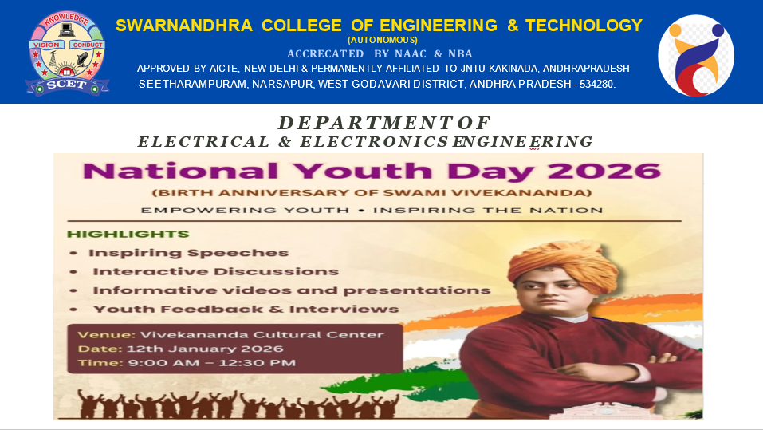

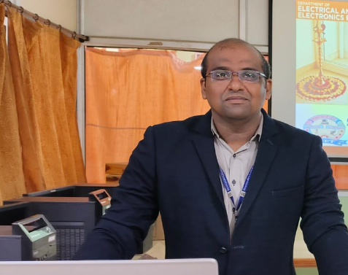
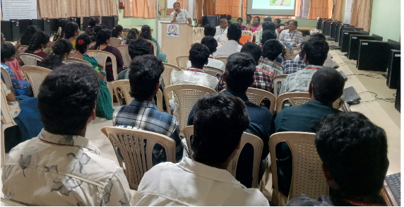
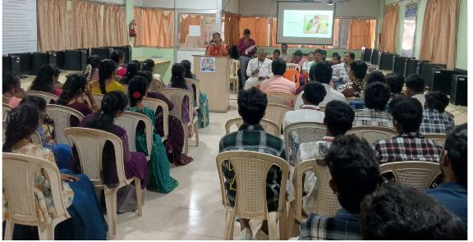
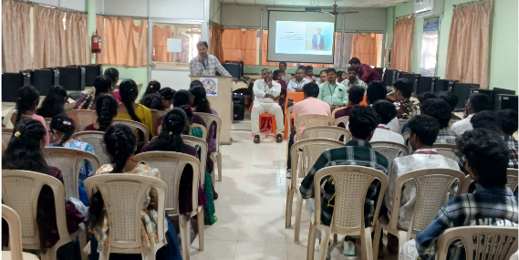

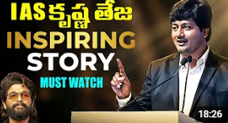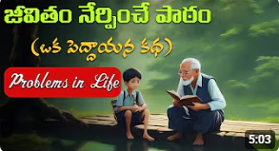

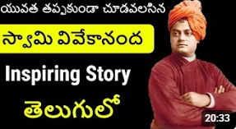
Participants List:
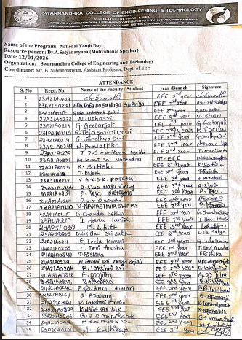

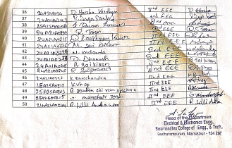

EEE-HOD

